## 總表

|  |  |  |  |  |  |  |  |  |
| --- | --- | --- | --- | --- | --- | --- | --- | --- |
| view | 欄子集視界 | | 列子集視界 | | 合併視界 | | 統計視界 | |
| 含主鍵 | 不含主鍵 | 含主鍵 | 不含主鍵 | 含主鍵 | 不含主鍵 | 含主鍵 | 不含主鍵 |
| insert | Ex1√ | Ex2X | Ex3√ | Ex4X | Ex5X | Ex6X | Ex7X | Ex8X |
| update | √ | √ | √ | √ | √ | √ | √ | √ |
| delete | √ | √ | √ | √ | X | X | X | X |

### --Ex1欄子集視界含主鍵

create view ex1 as

SELECT [客戶編號],[客戶名稱],[地址],[電話],[E-mail],[統一編號]

FROM [dbo].[客戶]

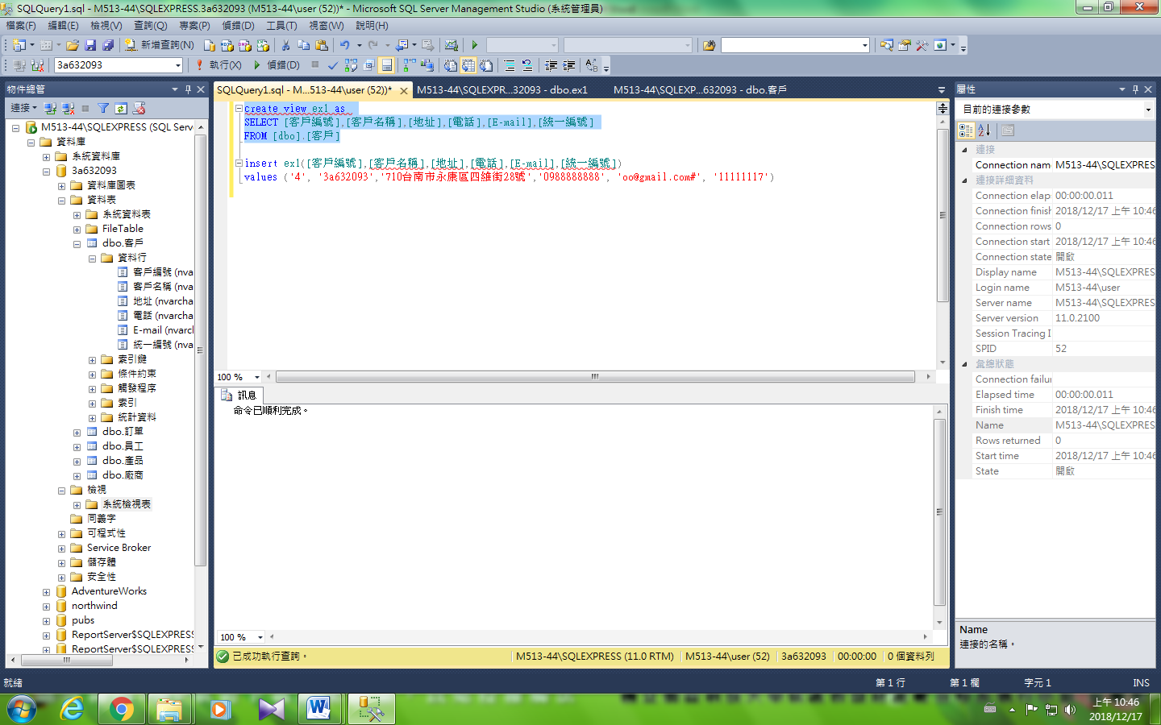

--新增

insert ex1([客戶編號],[客戶名稱],[地址],[電話],[E-mail],[統一編號])

values ('4', '3a632093','710台南市永康區四維街28號','0988888888', 'oo@gmail.com#', '11111117')

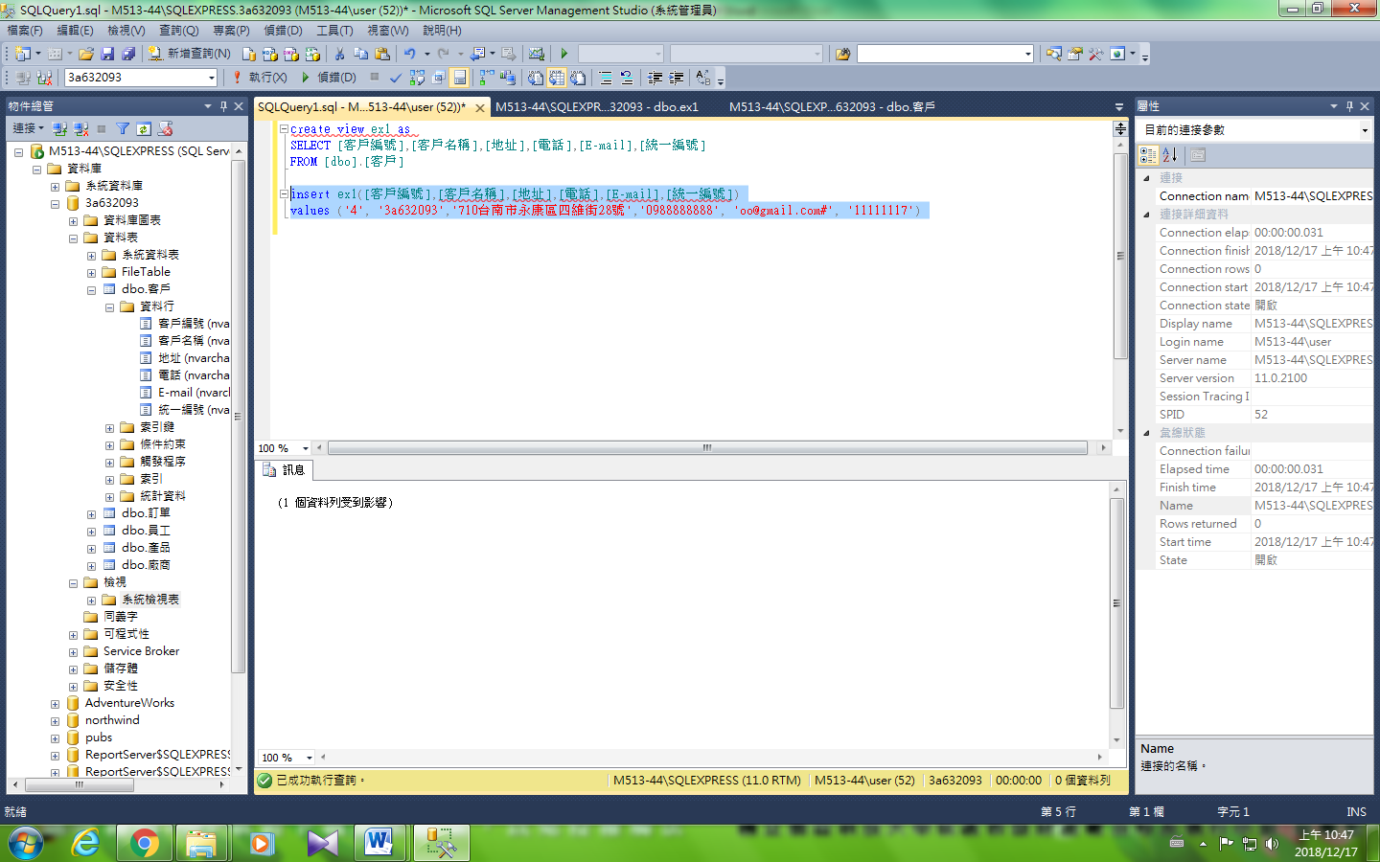

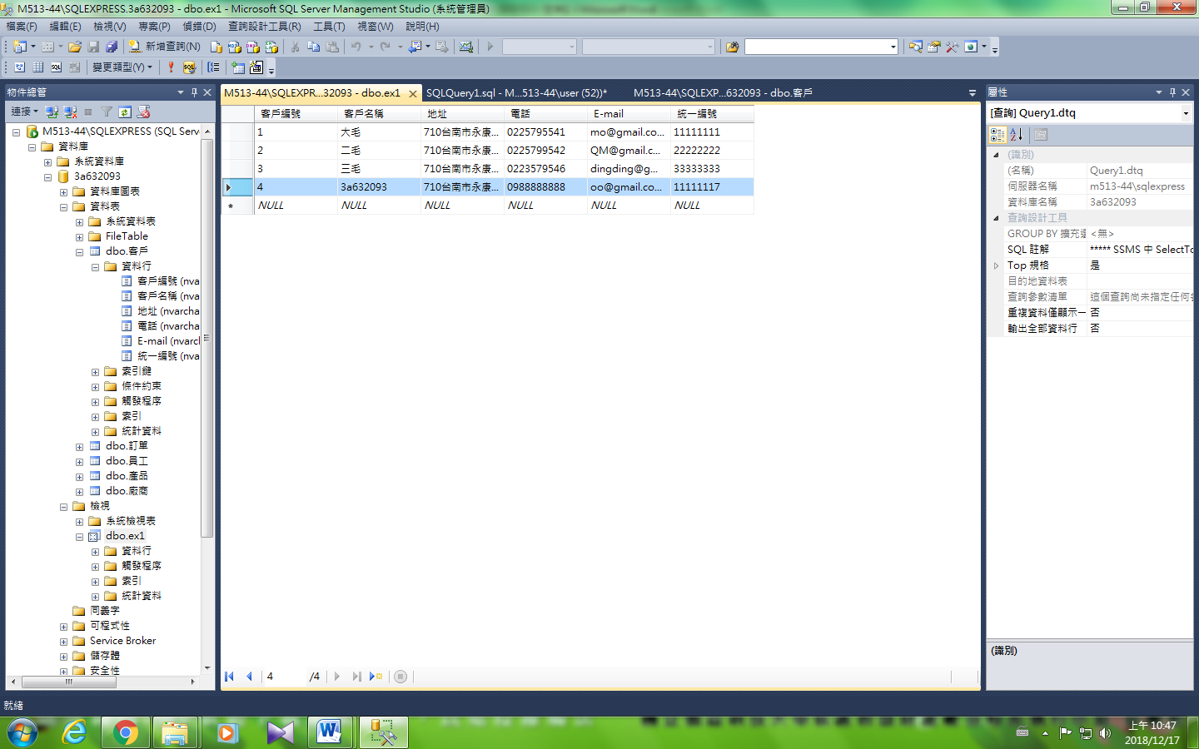

--更新

update ex1 set [電話] ='0977777777'

where [客戶名稱] ='3a632093'

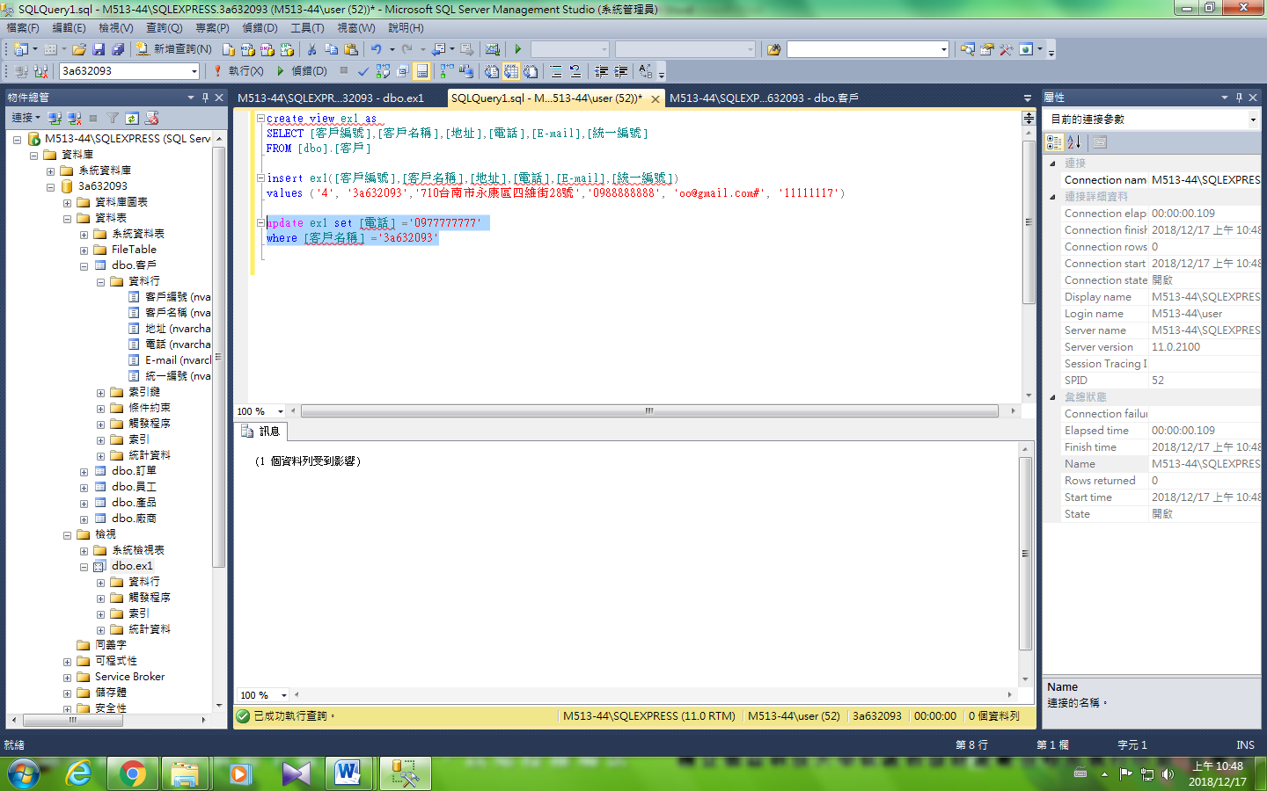

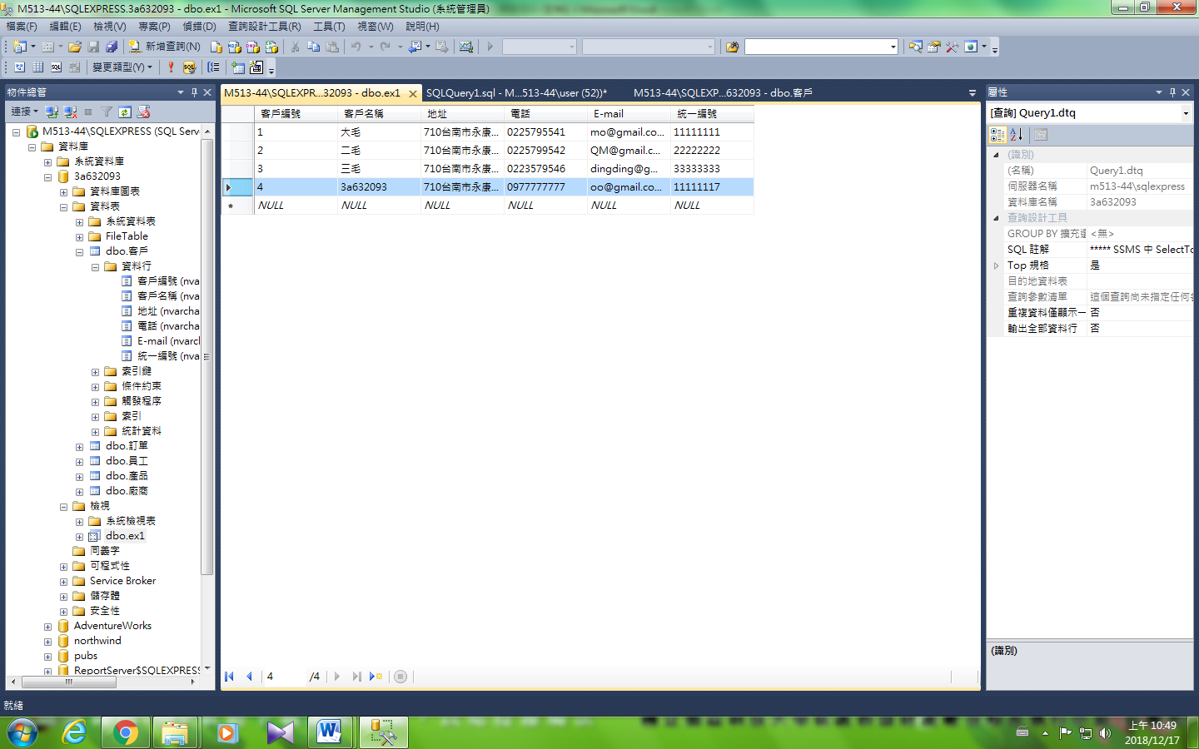

--更新主鍵

update ex1 set [客戶編號] ='5'

where [客戶名稱] ='3a632093'

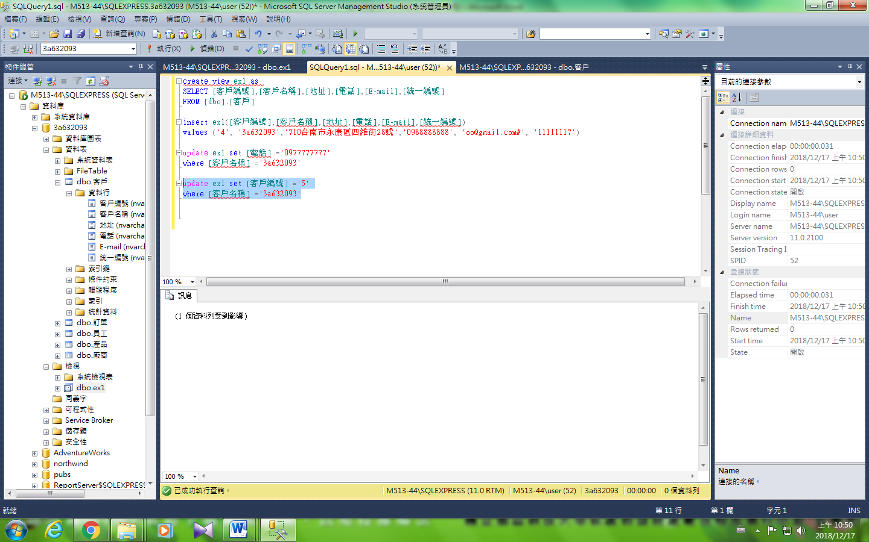

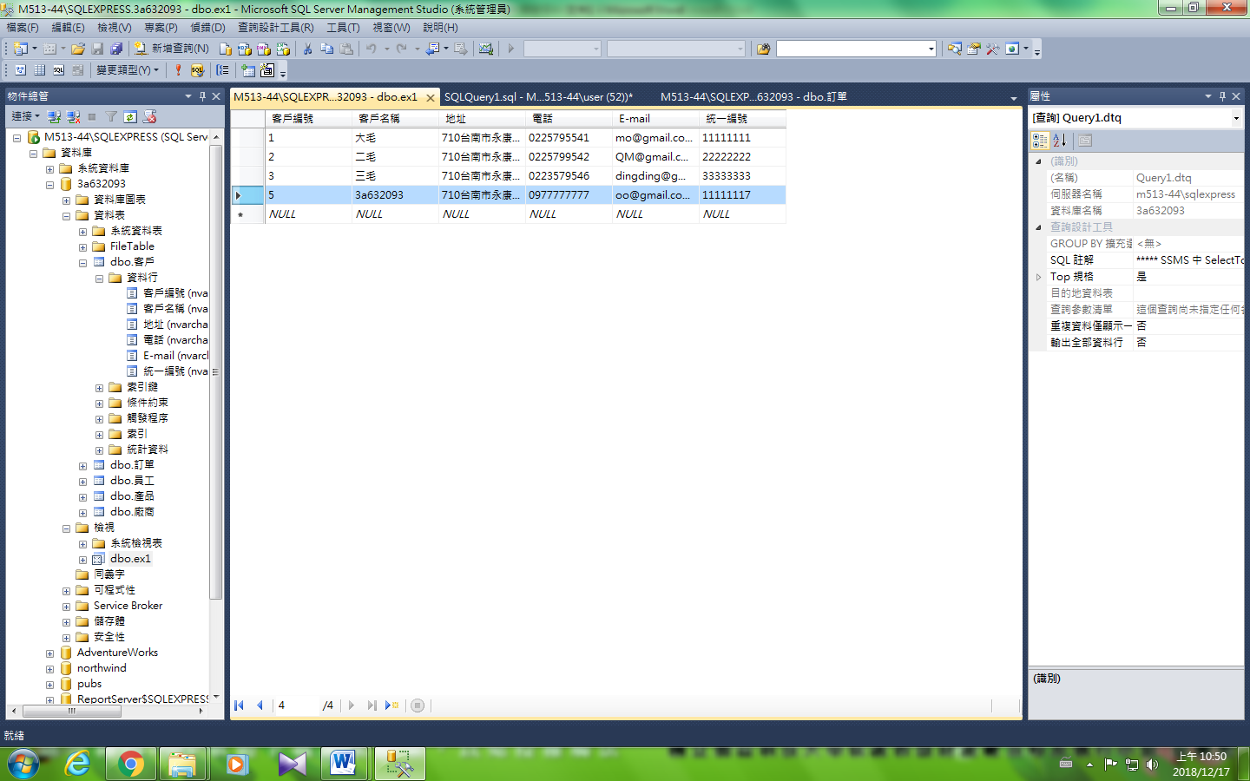

--刪除

DELETE FROM ex1 WHERE [客戶名稱] ='3a632093'

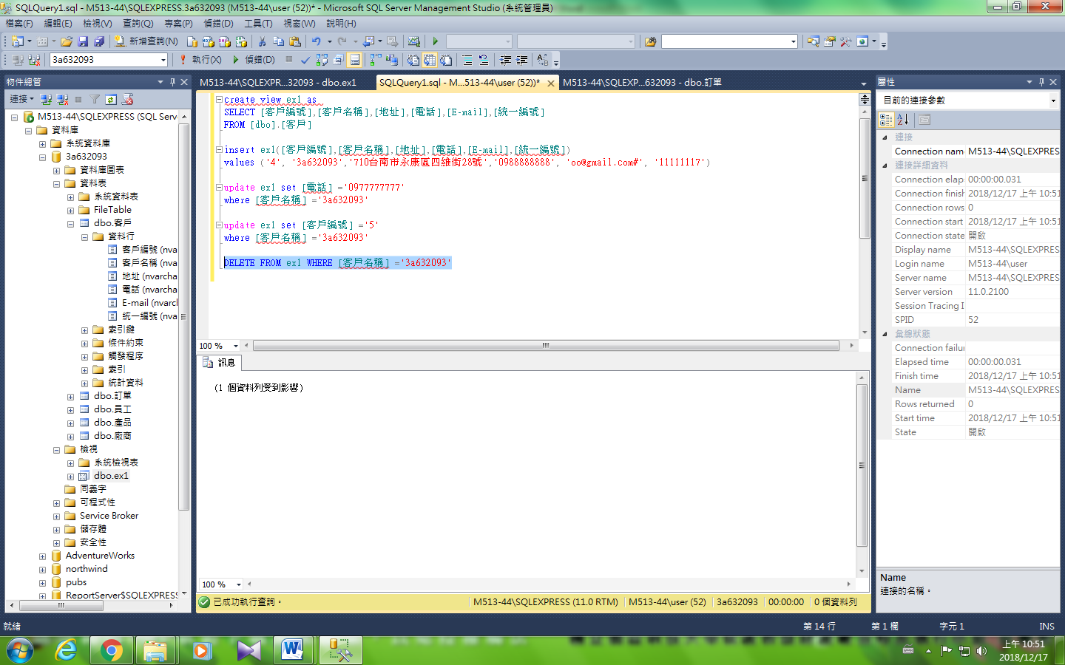

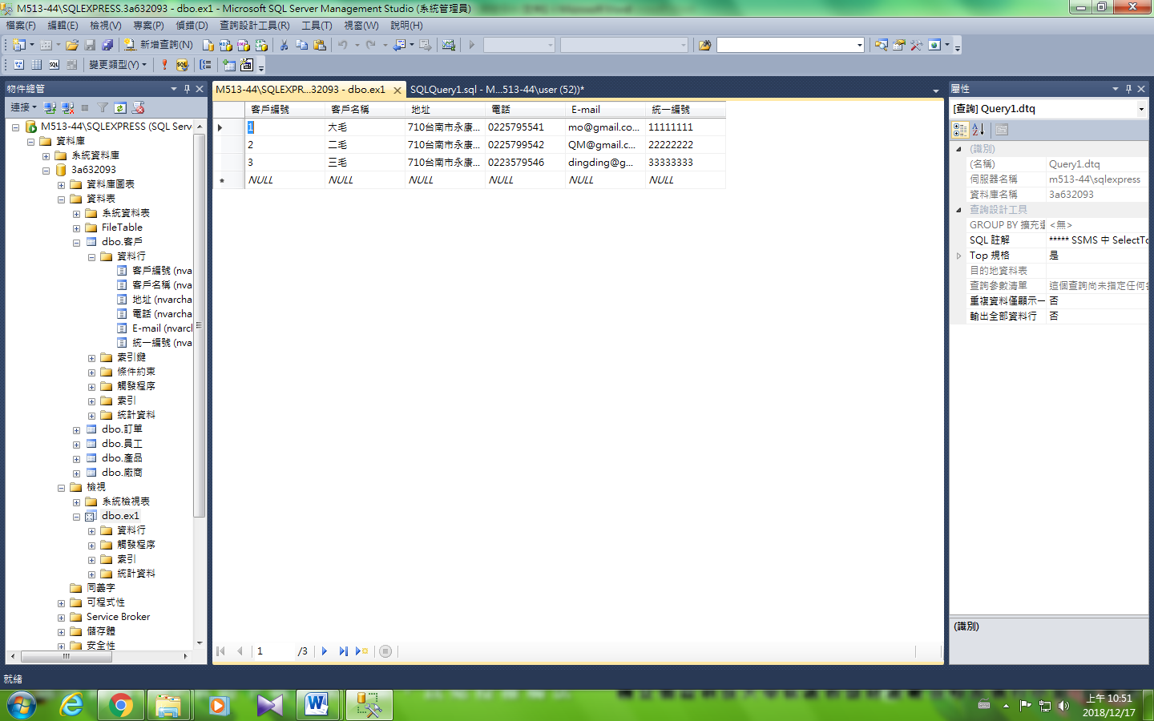

### --Ex2欄子集視界不含主鍵

create view ex2 as

SELECT [客戶名稱],[地址],[電話],[E-mail],[統一編號]

FROM [dbo].[客戶]

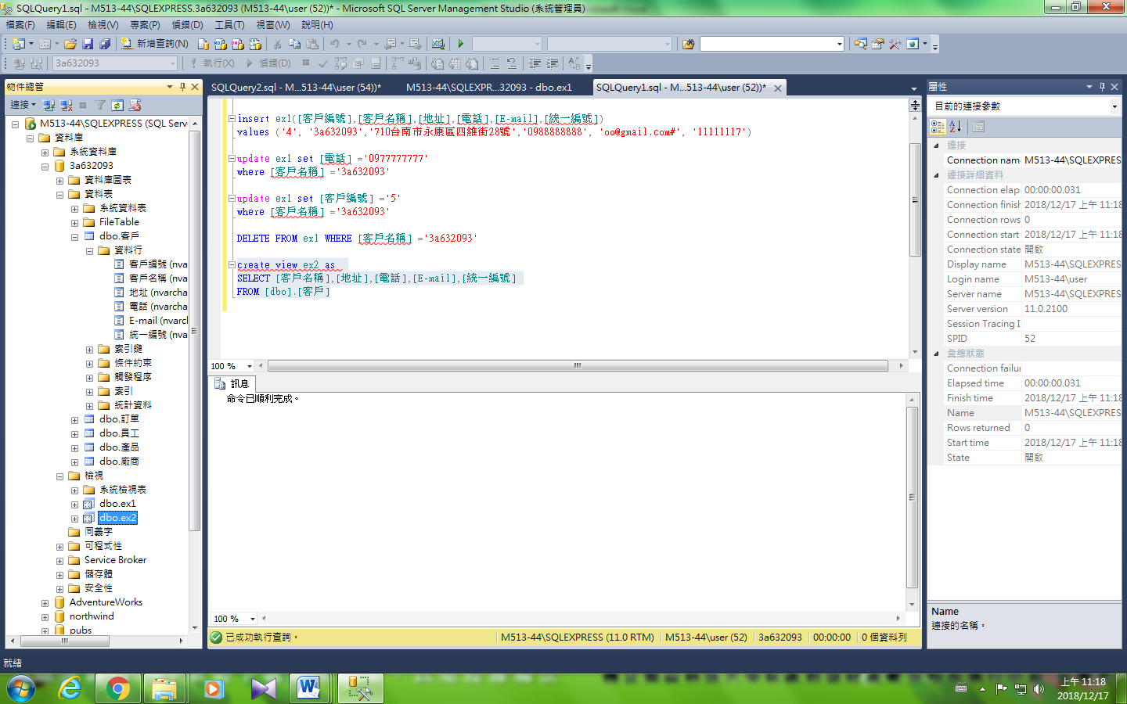

--新增

insert ex2( [客戶名稱],[地址],[電話],[E-mail],[統一編號])

values ('3a632093','710台南市永康區四維街28號','0988888888', 'oo@gmail.com#', '11111117')

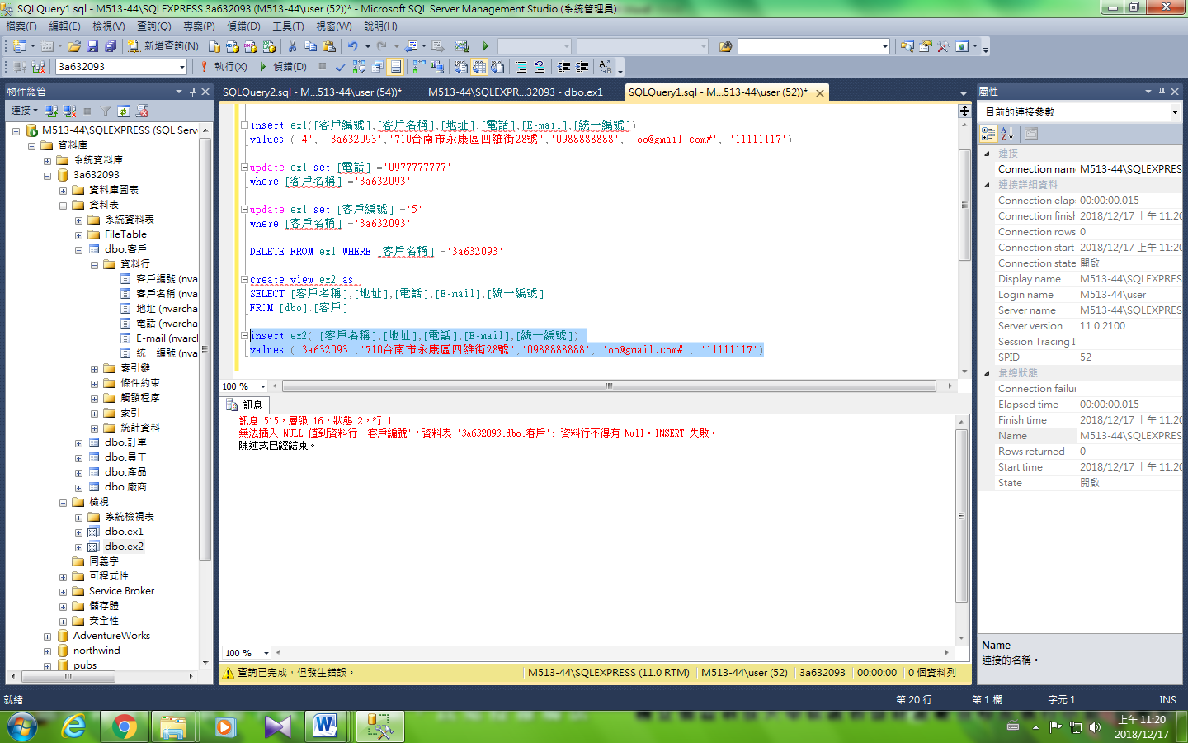

--更新

update ex2 set [電話] ='0977777777'

where [客戶名稱] ='三毛'

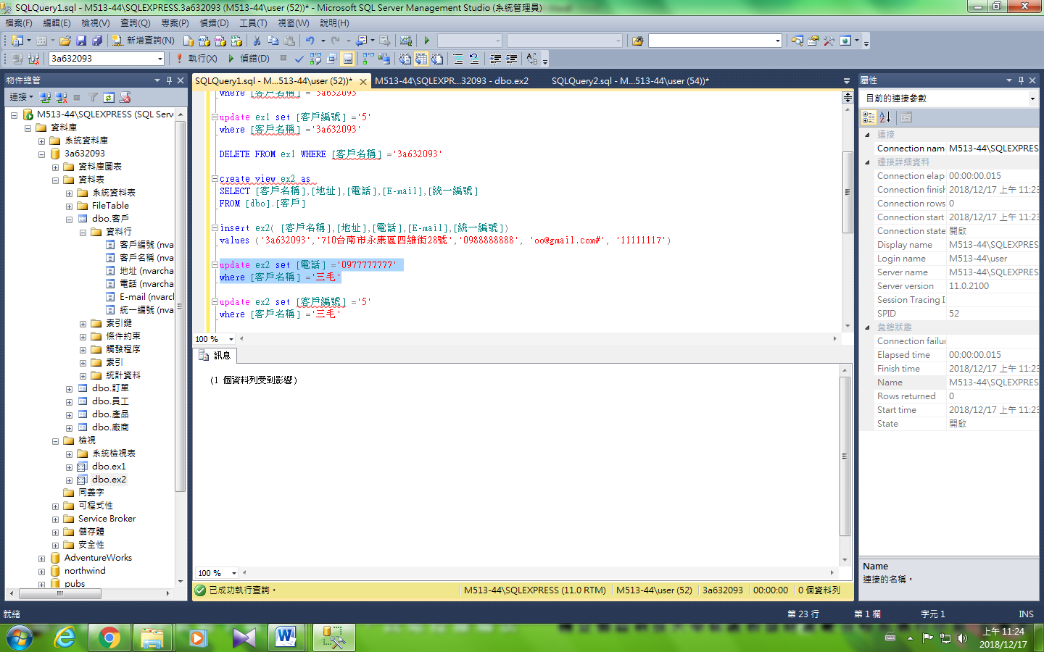

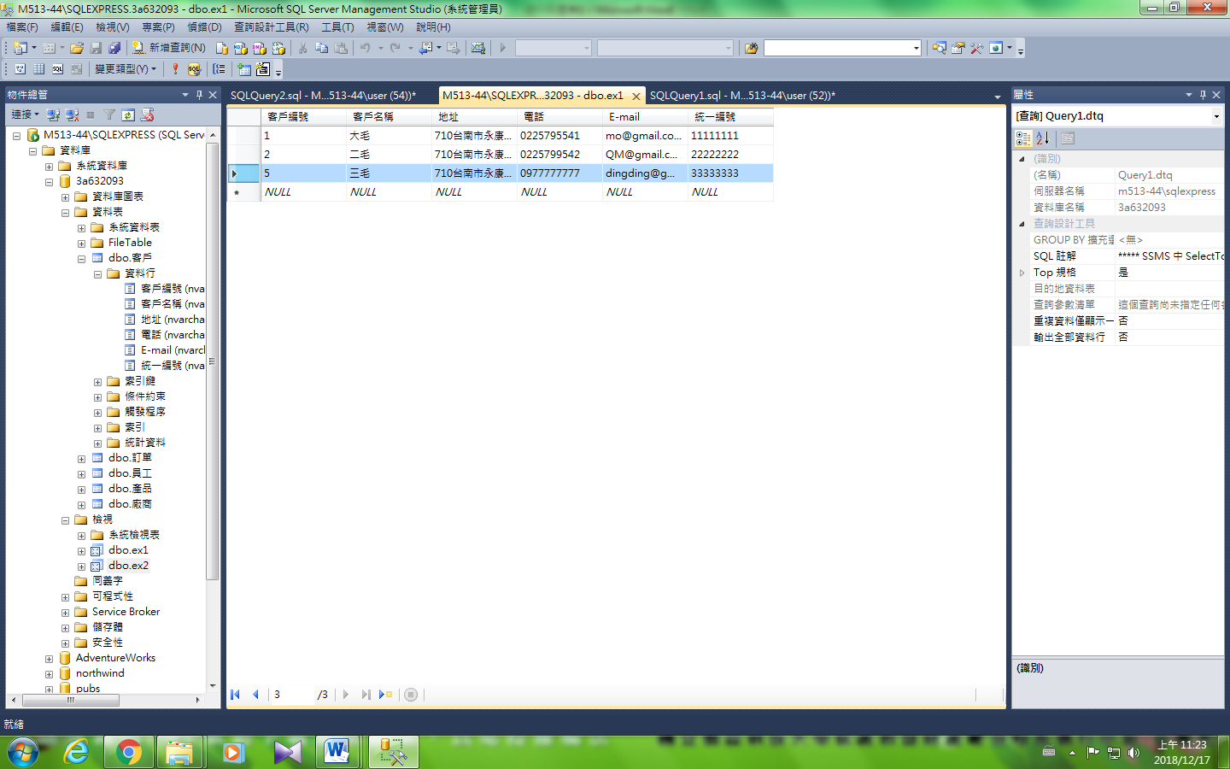

--更新主鍵

update ex2 set [客戶編號] ='5'

where [客戶名稱] ='三毛'

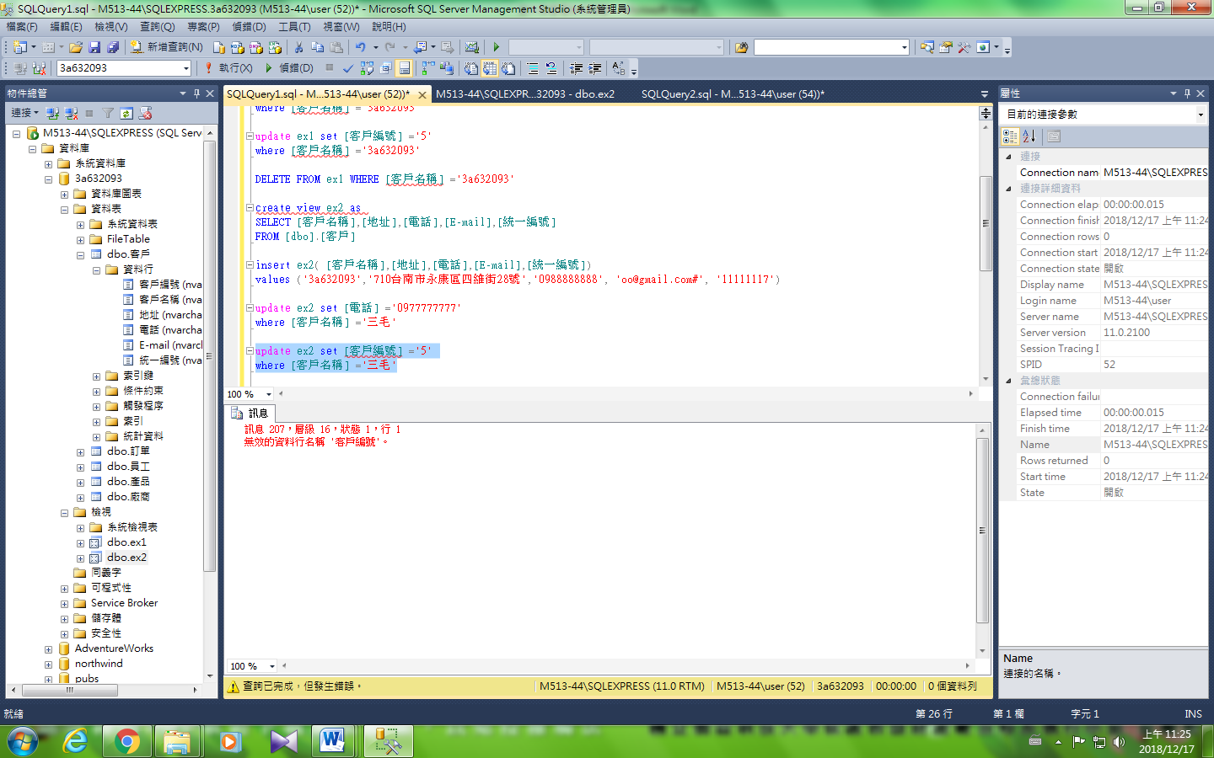

--刪除

DELETE FROM ex2 WHERE [客戶編號]= '3' (x)

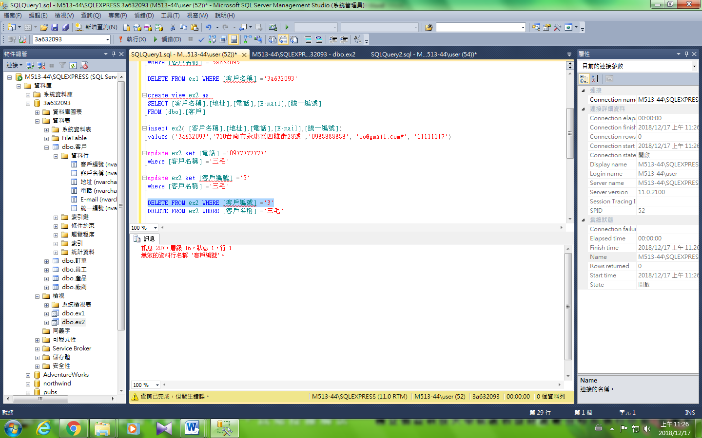

DELETE FROM ex2 WHERE [客戶名稱] ='三毛' (√)

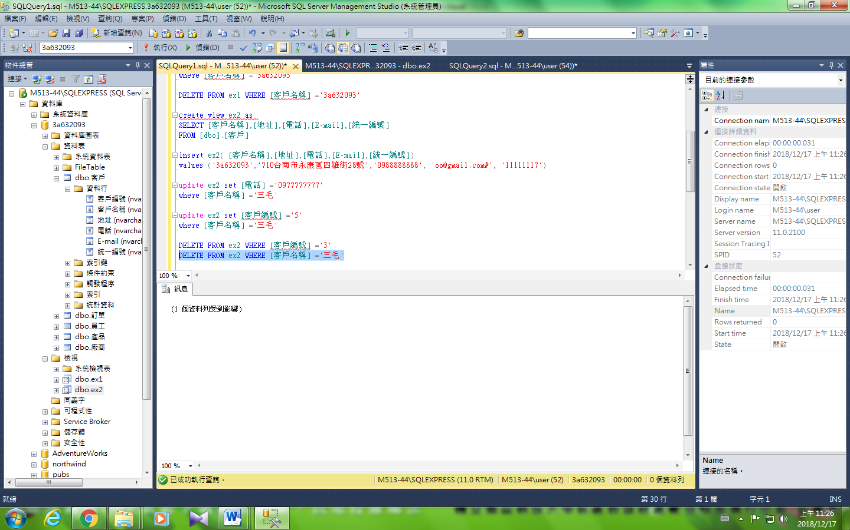

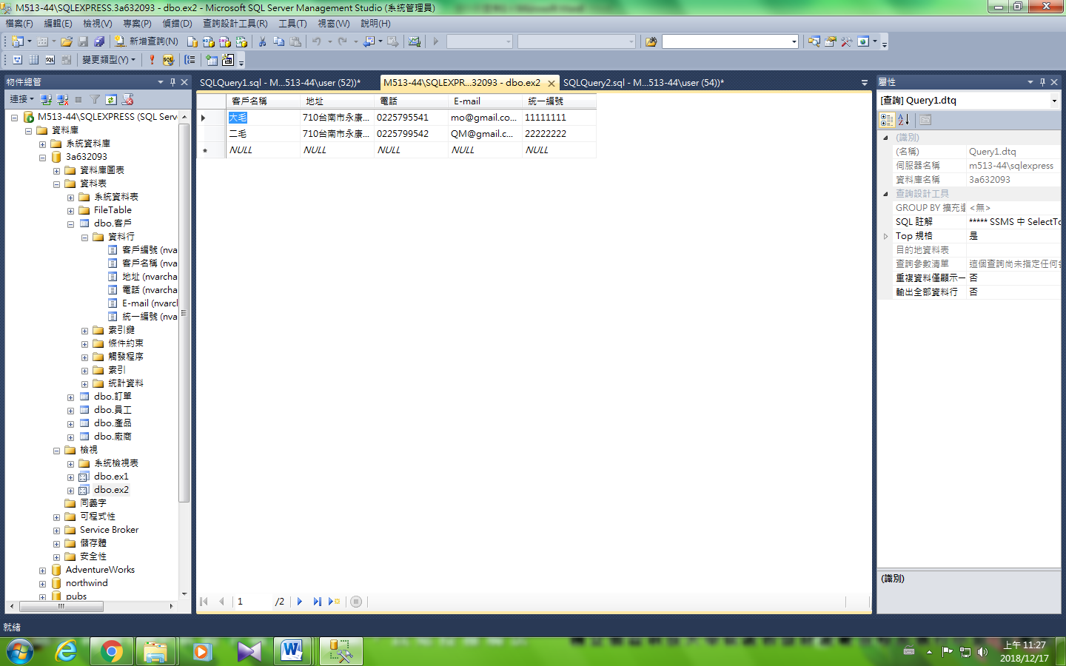

### --Ex3列子集視界含主鍵

create view ex3 as

SELECT *

FROM [dbo].[產品]

where [單價(100g)] > 200

ellipse

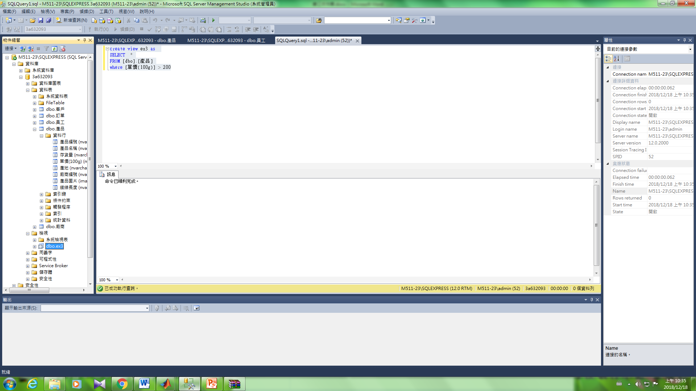

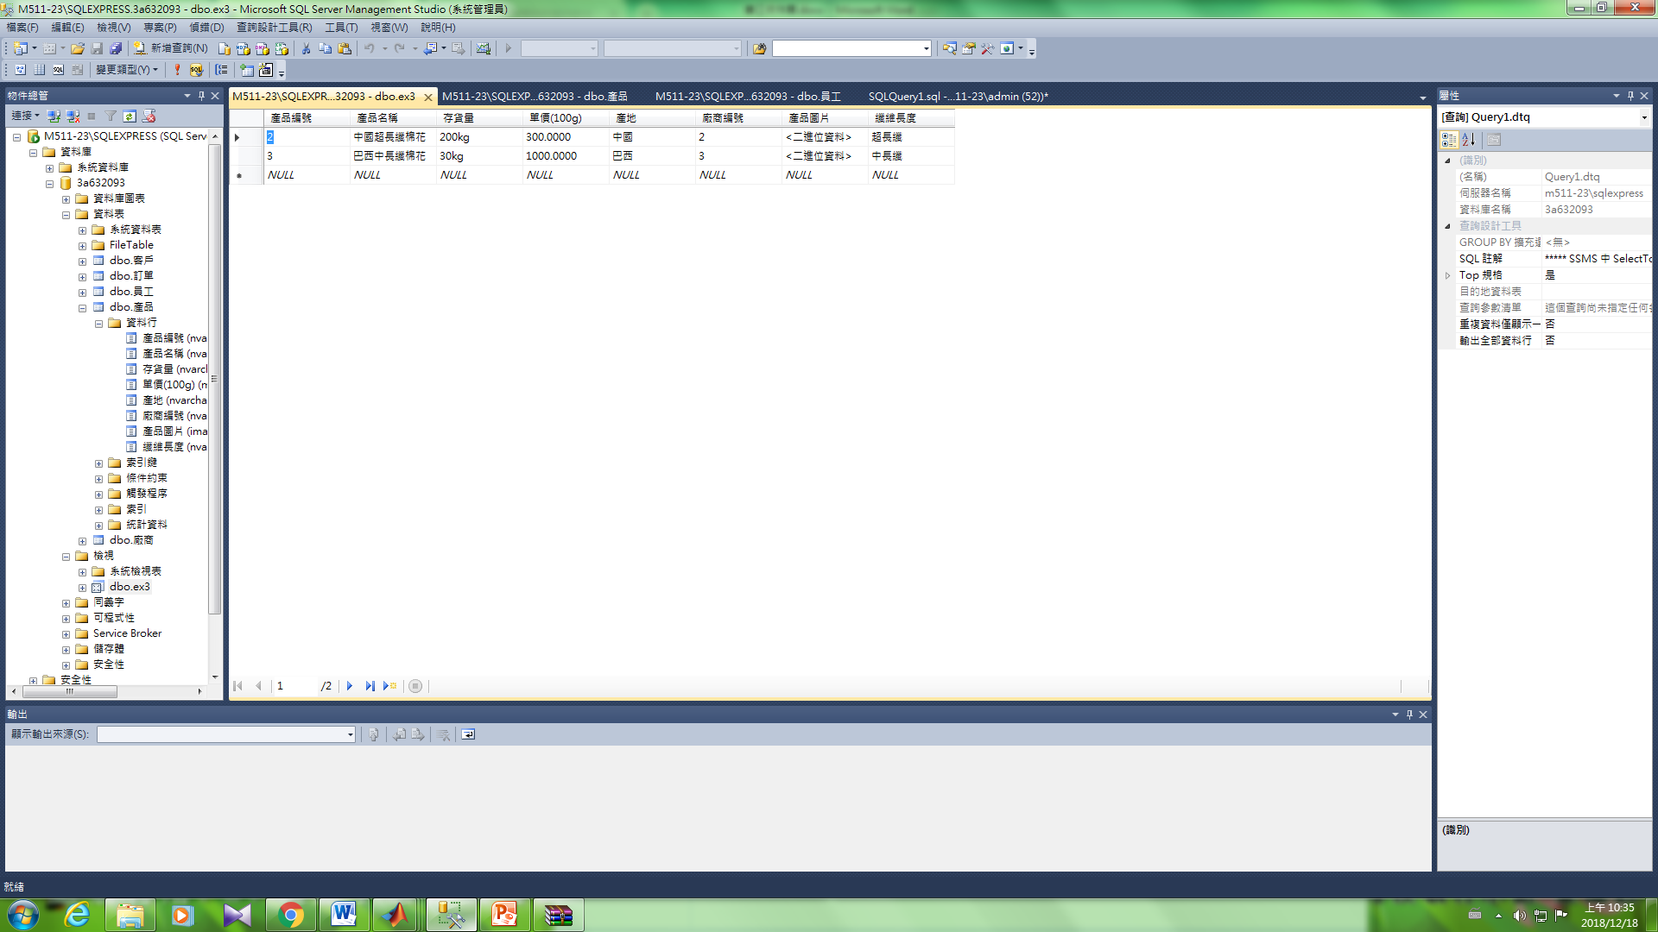

--新增

insert ex3([產品編號],[產品名稱],[存貨量],[單價(100g)],[廠商編號])

values ('4','3a632093','50kg', '350', '2')

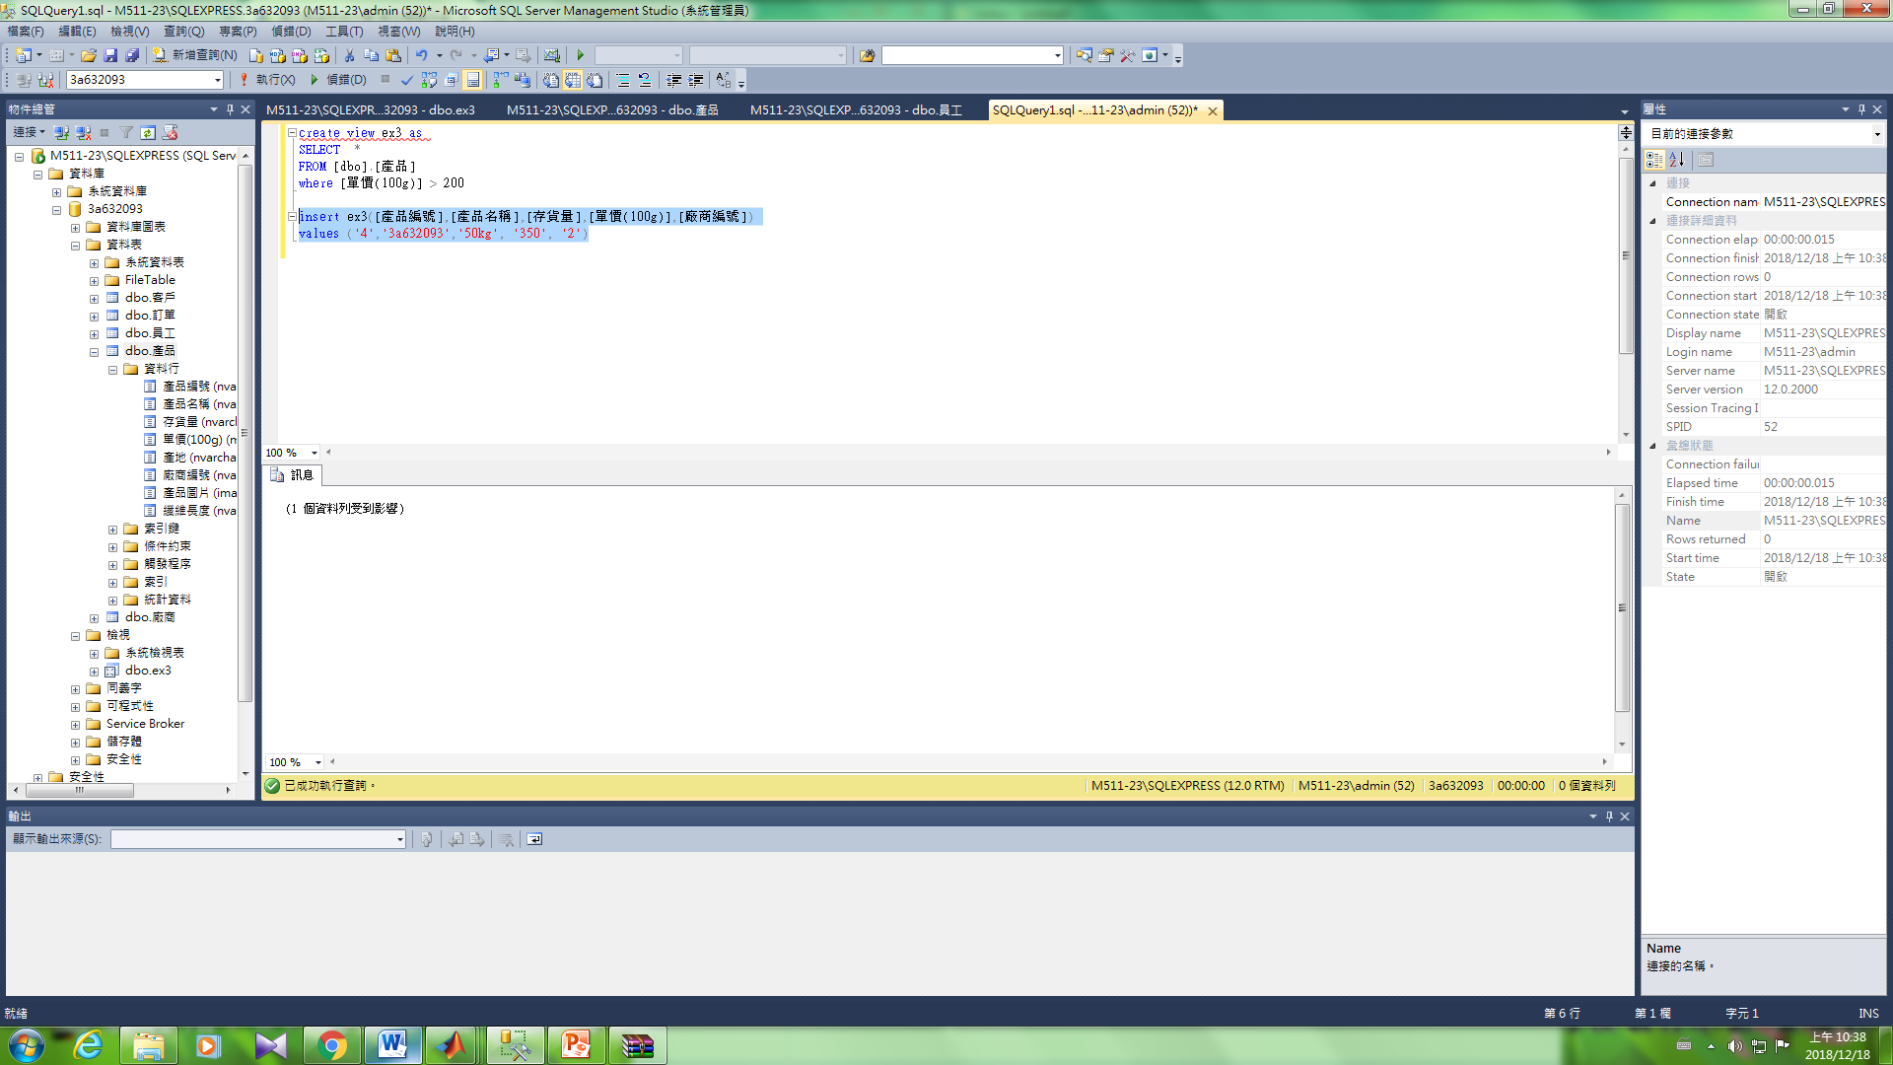

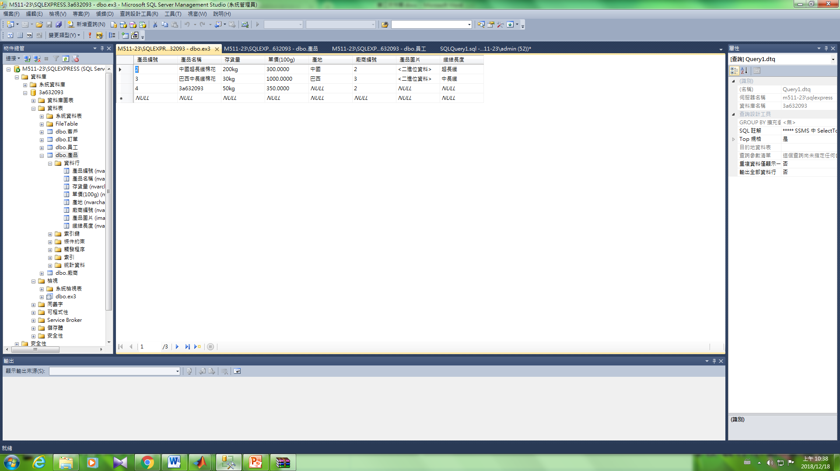

--更新

update ex3 set [存貨量] ='60kg'

where [產品名稱] ='3a632093'

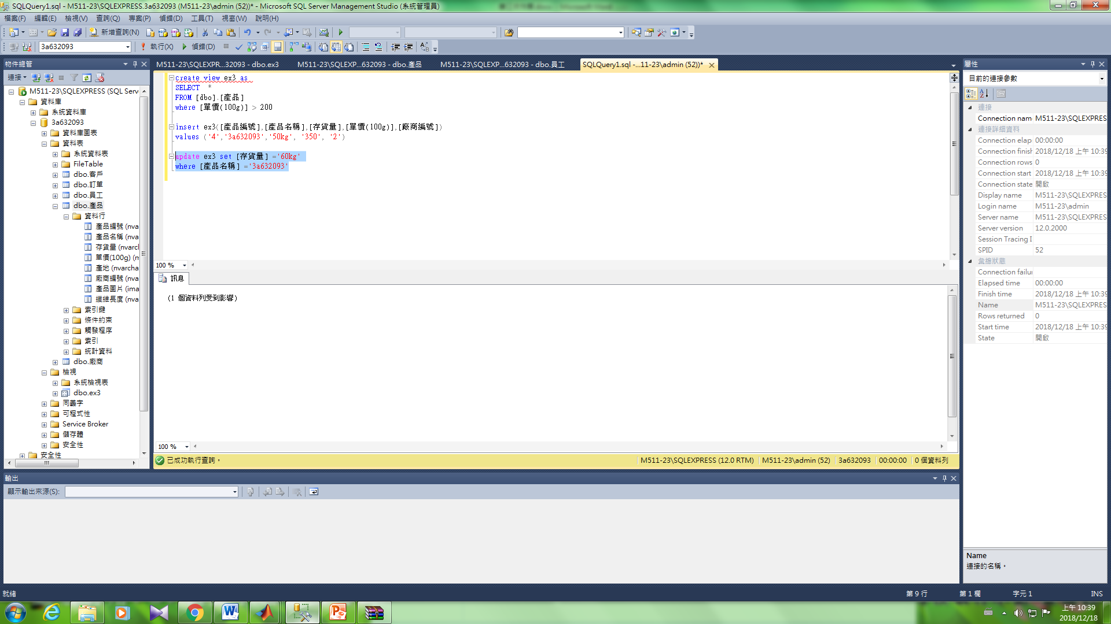

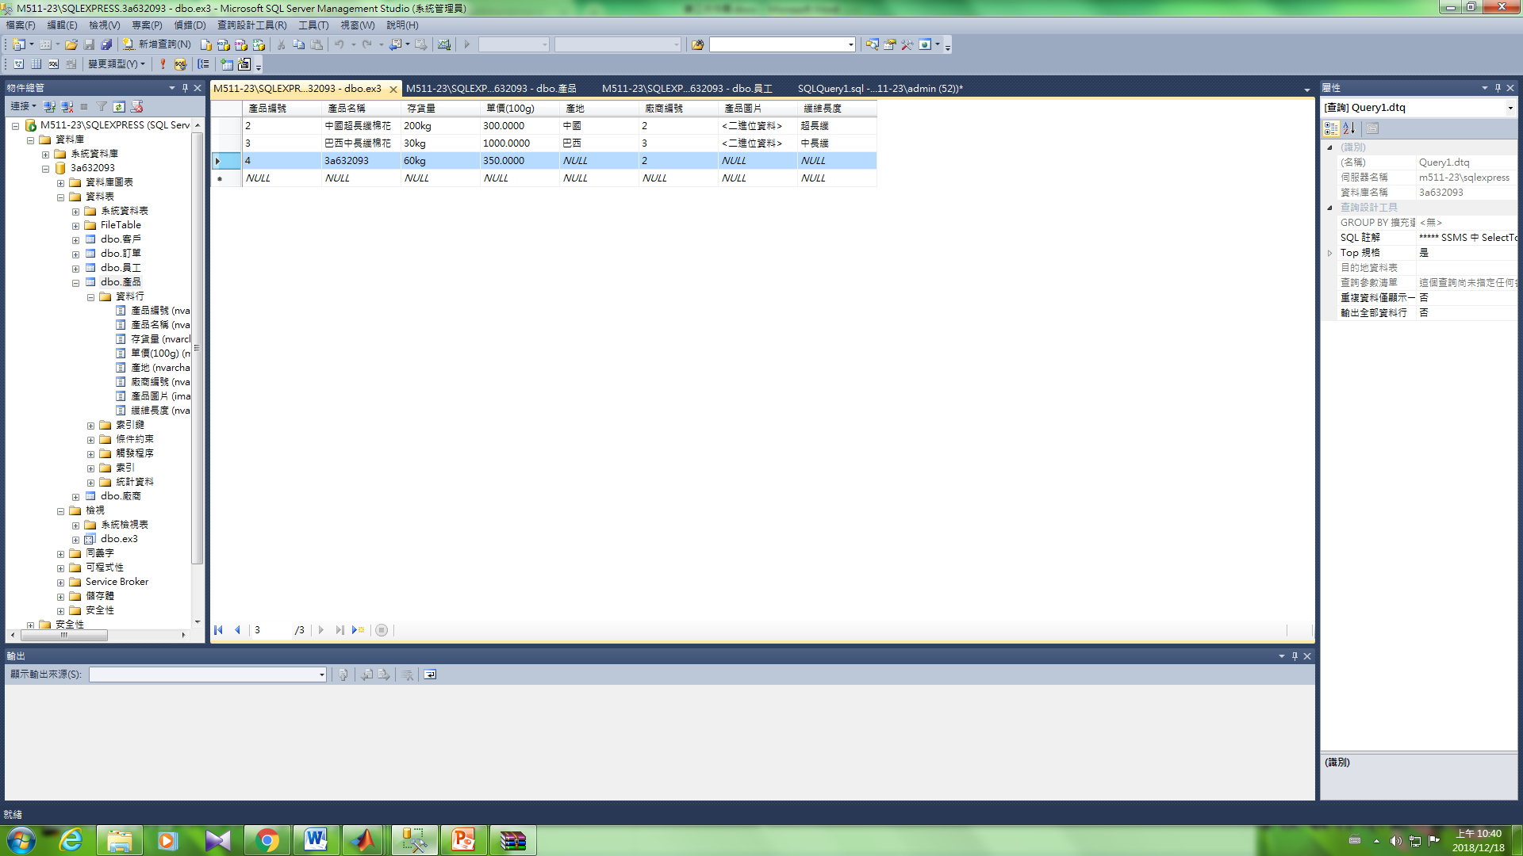

--更新主鍵

update ex3 set [產品編號] ='6'

where [產品名稱] ='3a632093'

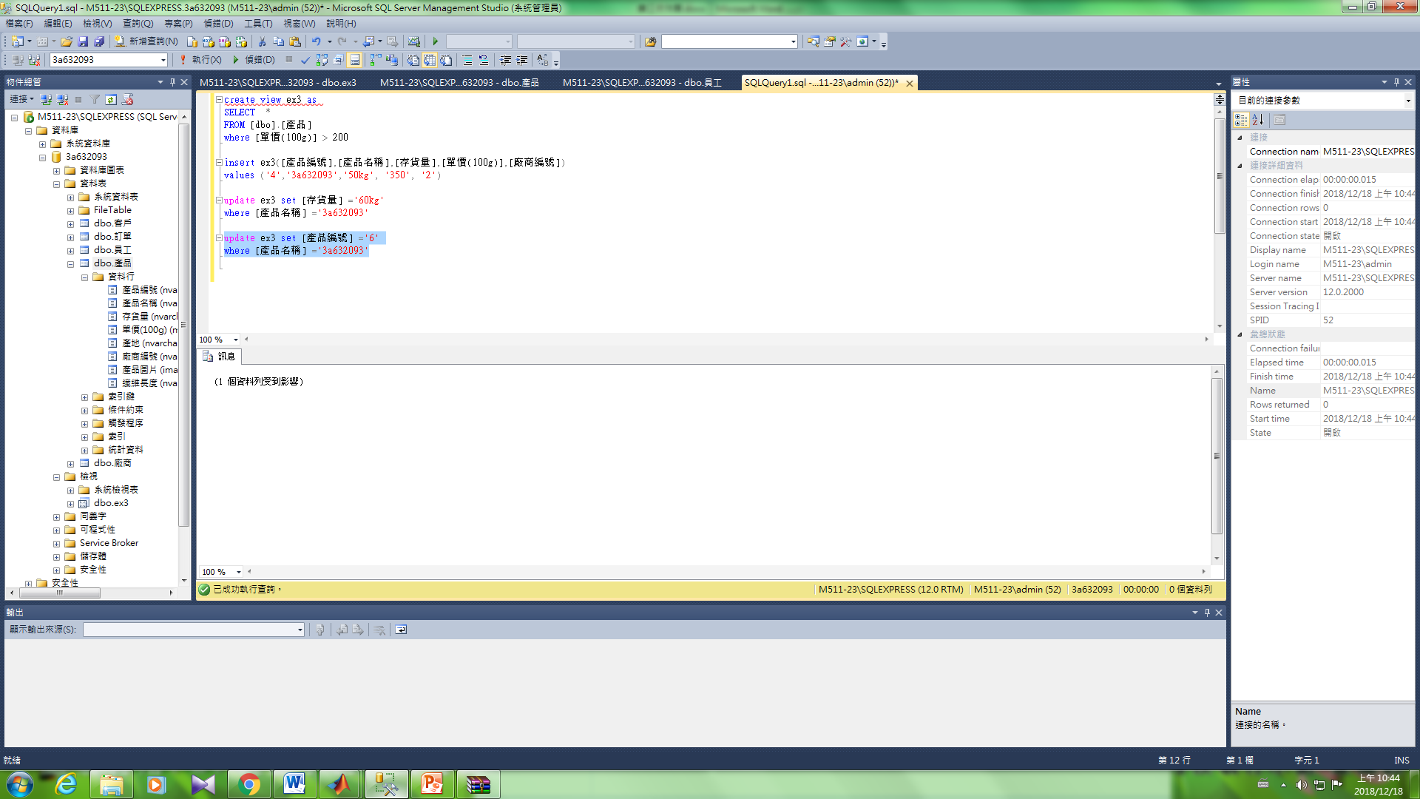

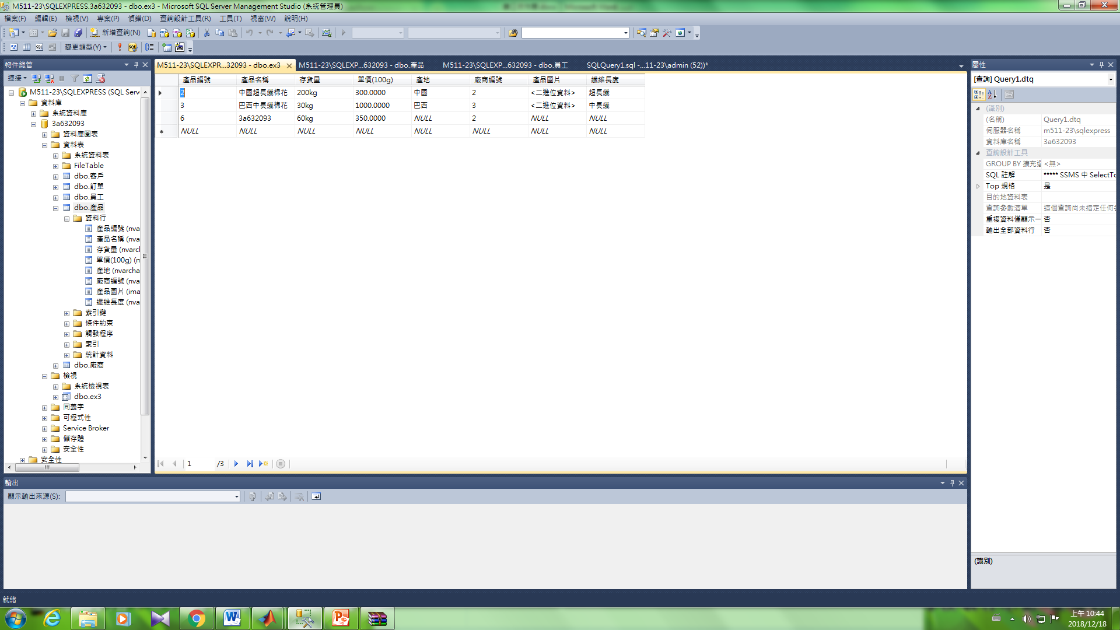

--刪除

DELETE FROM ex3 WHERE [產品名稱] ='3a632093'

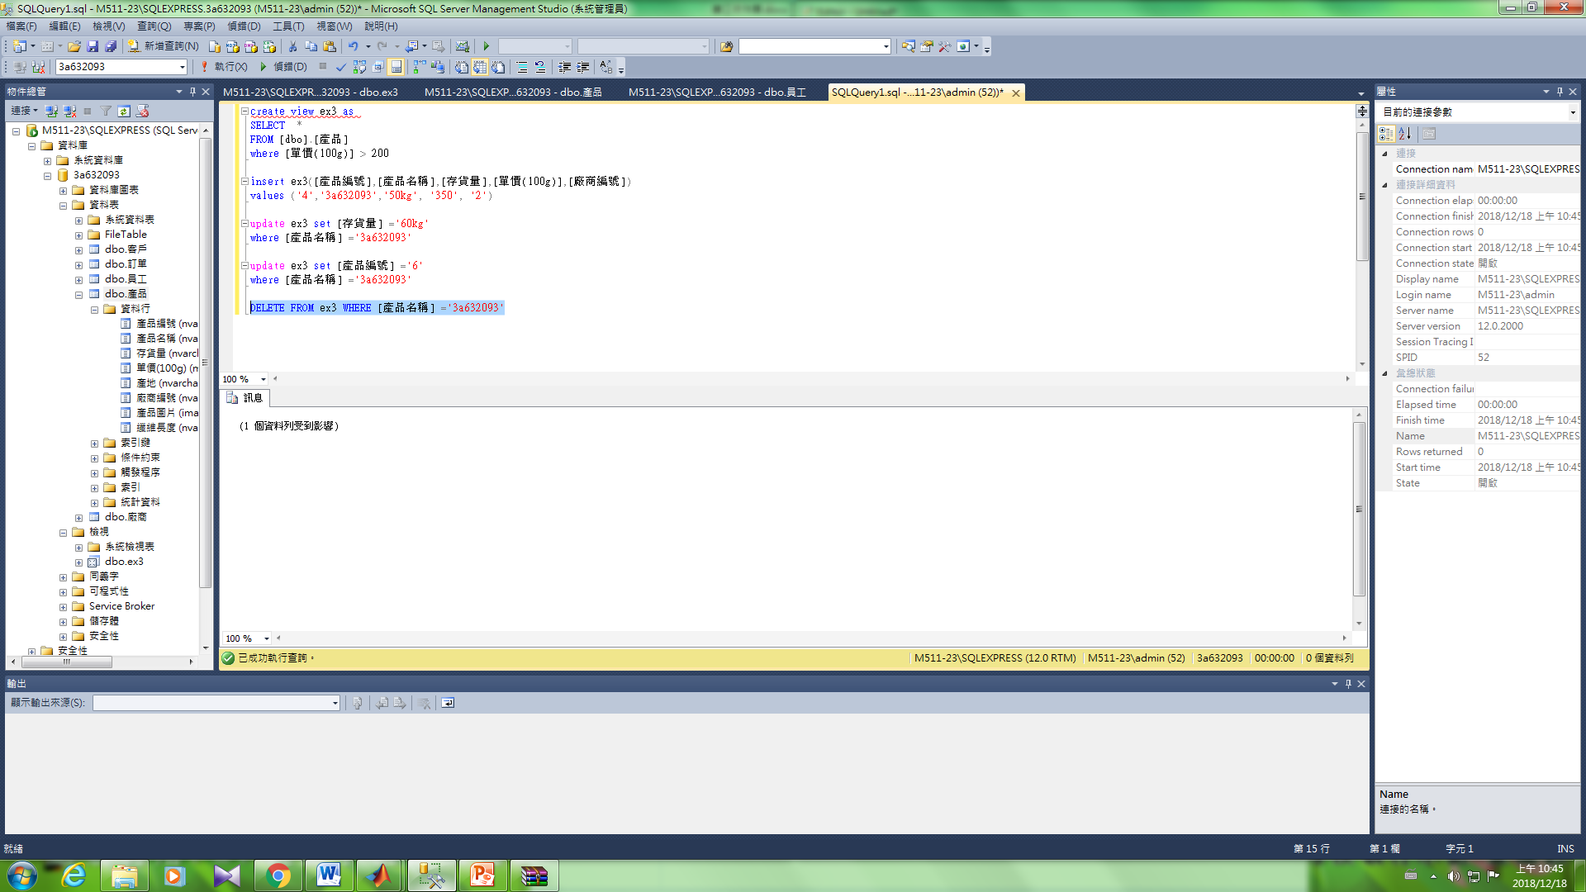

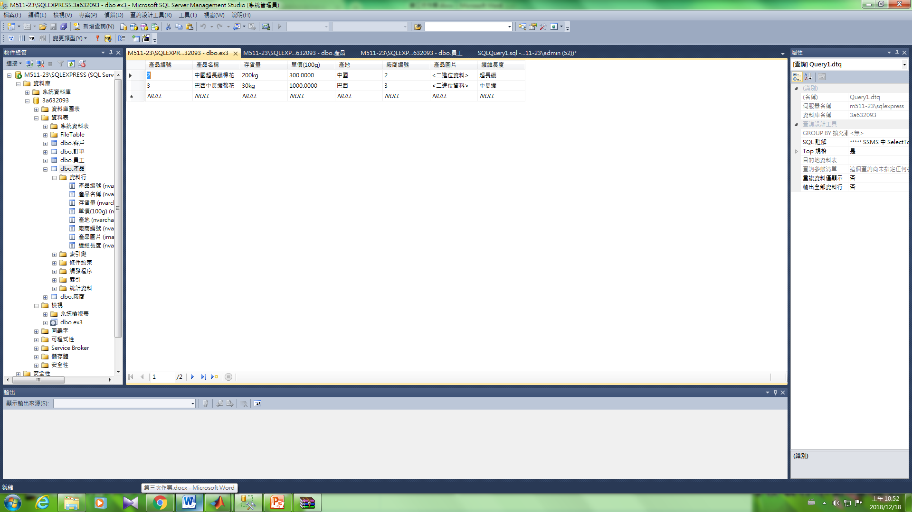

### --Ex4列子集視界不含主鍵

create view ex4 as

SELECT [產品名稱],[存貨量],[單價(100g)],[廠商編號]

FROM [dbo].[產品]

where [單價(100g)] > 200

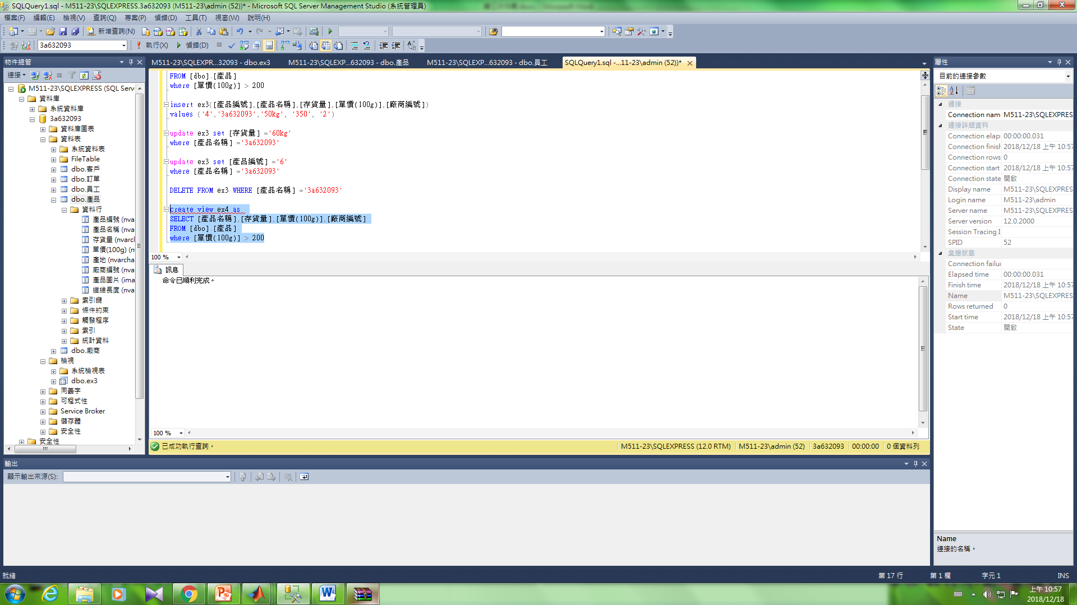

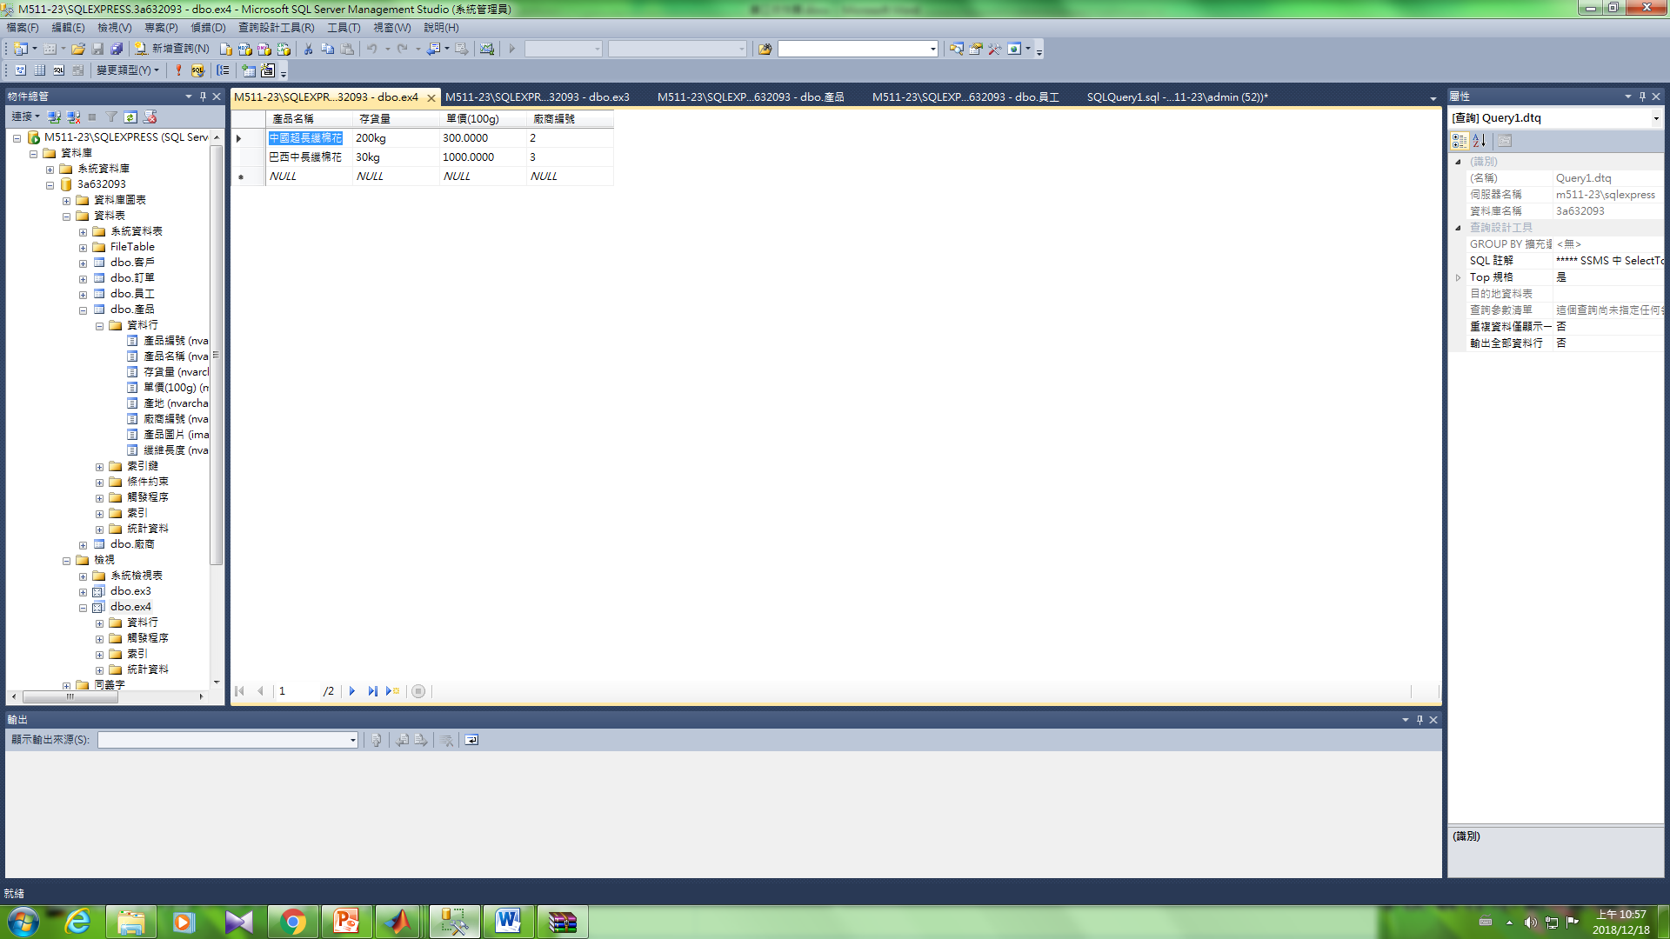

--新增

insert ex4[產品名稱],[存貨量],[單價(100g)],[廠商編號])

values ('3a632093','50kg', '350', '2')

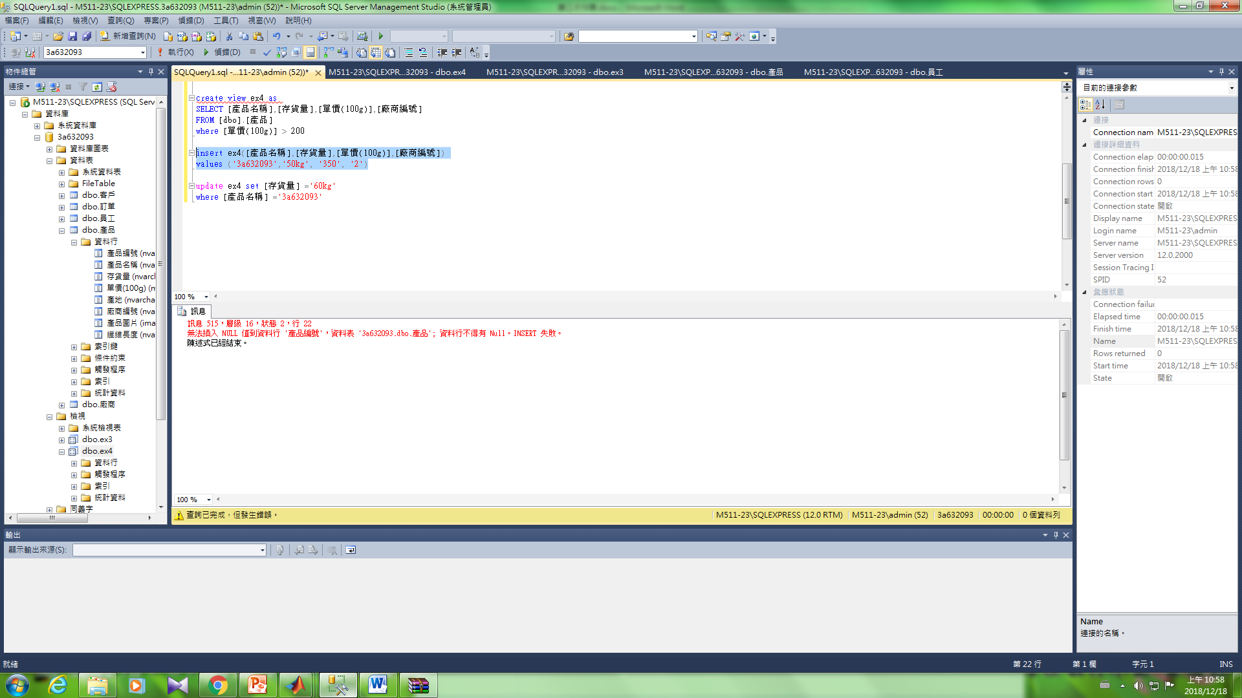

--更新

update ex4 set [存貨量] ='60kg'

where [產品名稱] ='中國超長纖棉花'

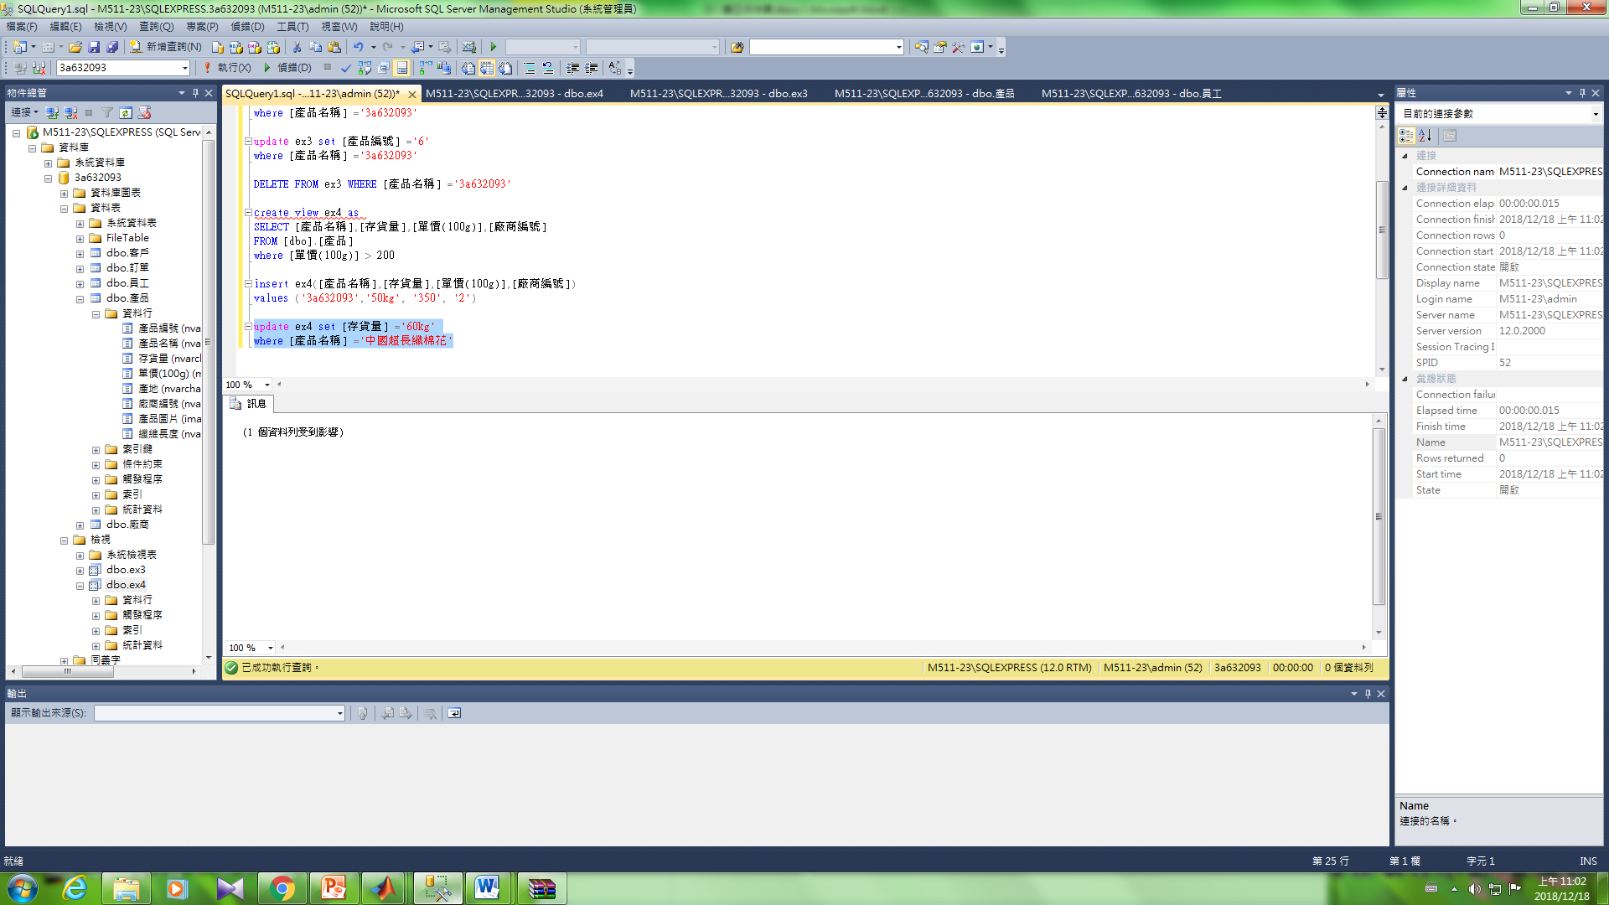

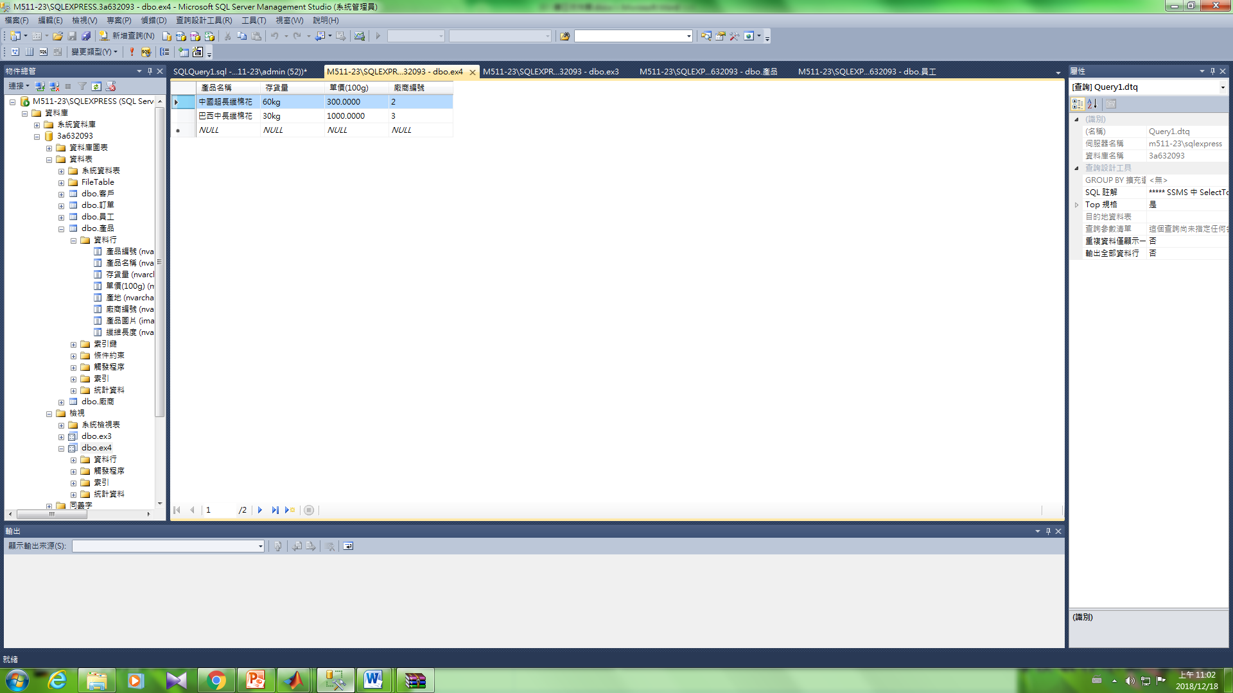

--更新主鍵

update ex4 set [產品編號] ='6'

where [產品名稱] ='中國超長纖棉花'

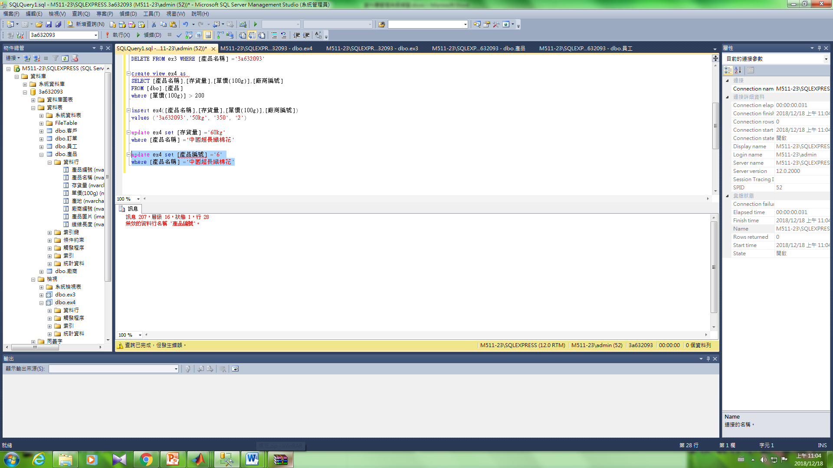

--刪除

DELETE FROM ex3 WHERE [產品名稱] ='中國超長纖棉花'

